Homeowners vs. Renters

Victor Adekola

Bowie State University

Professor Miller

Ctec 128

March 14, 2021

Homeowners vs. Renters

**Introduction**

**Overview of the Project**

The choice between owning or renting a housing unit is crucial and is always determined by numerous factors, such as economic, social, and environmental factors. Currently, housing units constitute a significant portion of most households' wealth in many countries across the world (Hankinson, 2018; Brunner, Ross & Simonsen, 2015; Bijlsma & Mocking, 2017). Therefore, a household unit choice has a critical effect on the economy (Bijlsma & Mocking, 2017). Homeowners can either buy a house or can have it through a mortgage. Homeowners pay a monthly mortgage to settle the secured loan. Homeowners have the opportunity of personalizing or decorating housing in their design. Besides, the housing unit owner can decide either to increase or decrease the value, especially when they want to sell.

On the other hand, renting a housing unit would require a monthly rent payment to live inside a home someone else owns. Renters cannot personalize or decorate the living space unless the owner of the housing unit is consulted. The rent price is determined by the landlord and keeps fluctuating, probably increasing.

**Brief Review of Literature**

Homeowners who cannot buy the housing unit will likely go for a mortgage. The mortgage should be paid and primarily done in four parts: Interest of the outstanding loans, principal loan, property taxes, and property insurance (Diamond, Guren & Tan, 2020). The benefit of owning a housing unit is the likelihood of the unit's appreciation, implying the house is more worth than the original price when owners decide to sell such as house (Bijlsma & Mocking, 2017). With this appreciation and payment installment, there is a net gain over the buying price. The downfall only comes when the value of the home depreciates, implying the housing unit is less worth than the original price. The homeowners maintain and repair the building and the property, so it is critical to have enough savings for unexpected repairs (Diamond, Guren & Tan, 2020).

Renters have landlords who charge them monthly payments for staying in their homes. Indeed, the rental agreement is used to bind a contract between landlords and renters, so renters need to make monthly payments under the agreement to stay in the home (Brunner, Ross & Simonsen, 2015). When renting, landlords are responsible for carrying maintenance and repair costs for the building and property that are pretty substantial considering replacing an air conditioner (Bijlsma & Mocking, 2017). It is beneficial to renters because it is useless to save money to cater for maintenance and repair costs. Renters are also advised to have renters insurance on their valuables in the housing unit. Rent prices may fluctuate over time-they either increase or decrease. Ideally, renters do not control the rent paid and changes subjected to the rent price (Diamond, Guren & Tan, 2020). Perhaps, the rental agreement limits changes on the rent price or improvements to the home.

In some cases, landlords request security deposits, which are refundable upon assessing the damages caused to the property. The advantage of renting is about mobility. For whatever reasons, renters can easily pack up their belongings and leave without worrying about selling the property. Finally, renters cannot be worried about house depreciation since they are not responsible for maintenance and repair.

According to Diamond, Guren, and Tan (2020), the total number of households in the U.S rose by about 8.1 million between 2011 and 2020. Perhaps, over this decade, homeowners have not increased due to the housing crisis's effects (Diamond, Guren & Tan, 2020). Simultaneously, renters increased significantly from 41.2% to 46.6% (Diamond, Guren & Tan, 2020). Certain demographic groups like youths, nonwhites, and less education tend to have the possibility of rent, unlike other individuals. The rental rates keep increasing over time. Nevertheless, increased rent has made some groups rent instead of owning a house.

**Concept Map and Discussion**

The choice of either owning or renting a housing unit depends on four factors as depicted on the concept map. These factors include education, age, income, and race.

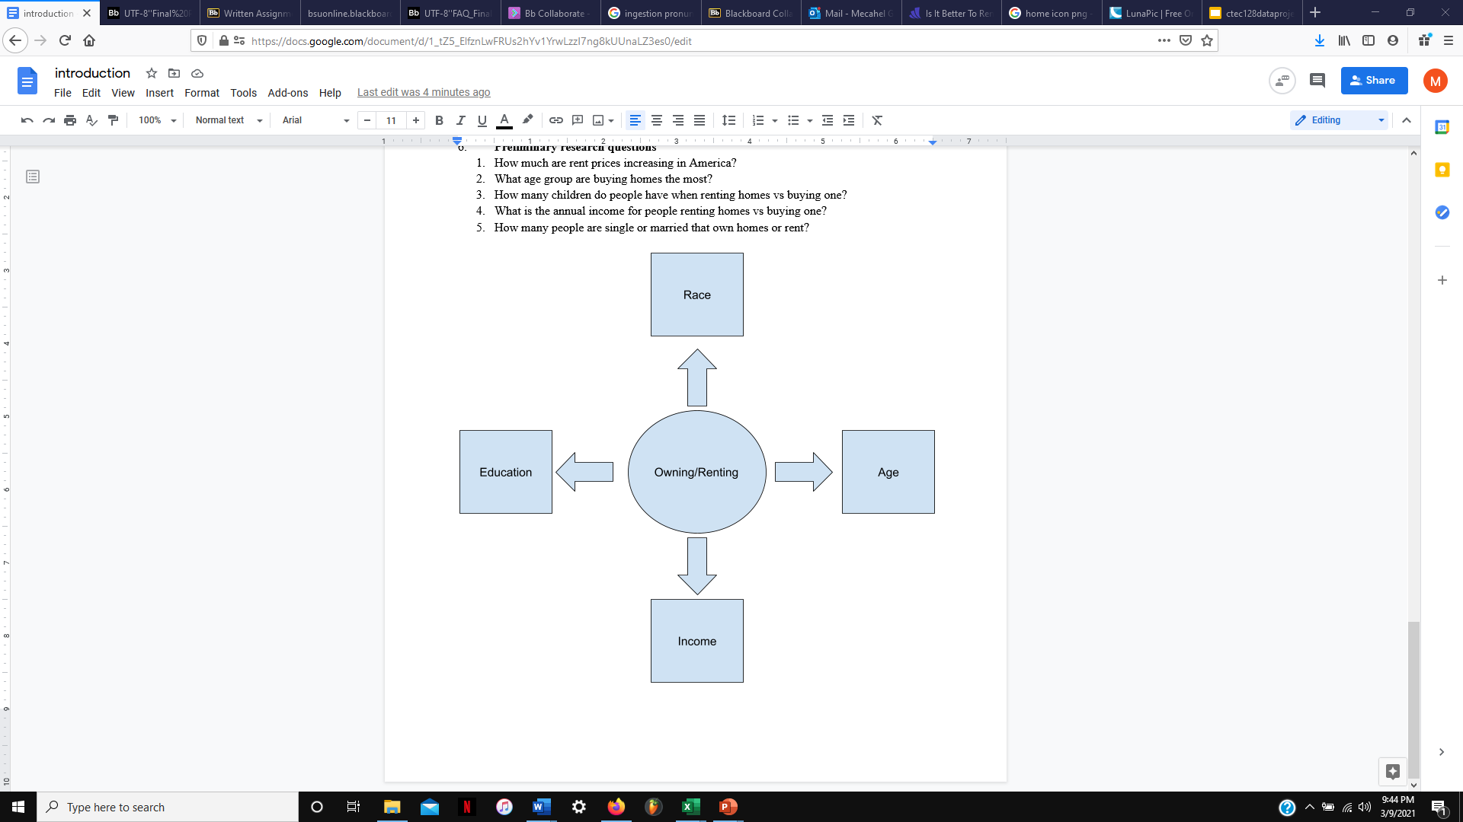

**Figure 1: Concept Map**

Income is a critical factor in the choice of either owning or renting a house. Enough money would make an individual choose a housing unit or acquire a mortgage or loan because there is enough money for down payment or monthly payments. In case another seems not to have enough money to pay as a downpayment or monthly payments if the property was acquired through a mortgage, he will probably opt for renting. Age is also a critical factor in homeownership. When people become older, they settle for a house, and they can either choose homeowning or renting depend on their status in society.

Another critical factor in homeownership is the level of educational attainment. College graduates do not like becoming renters; instead, they prefer owning a housing unit. In comparison, people who did not complete high school tend to become renters. Also, race is typical when it comes to homeowning or renting. Black and Hispanic households are more likely than white families to rent their homes. The major races and ethnic groups in the U.S. have a high possibility of renting a house.

Description of the Problem

**Project Objectives**

The objectives of this project are as stated below:

* Understanding the difference of trends between people buying/renting a house
* Providing the reader with data on the demographics of who owns/rents a house
* Finding out average income for homeowners and renters

**Project Research Questions**

From the above objectives, the following research questions were developed:

* What is the difference between genders being homeowners or renters?
* Are people who graduate college more likely to own a home than people who didn't graduate high school?
* What is the average income for people renting homes vs. buying one?
* Which race of people of color is renting or owning homes the most?
* What age group is buying homes the most?

**The Pipeline**

**Data Ingestion**

The Data science pipeline requires a detailed approach to get relevant data to be used in the analysis. The study would be based on the research questions and research objectives to offer relevant information on the topic. The variables needed are income, race, school attainment, age, gender, and marital status. The housing file was 1,548, 187, and the person file was 2 097,150, which was reduced by wrangling. Before wrangling person's file was about 3 645,000. This data was critical in the data wrangling process.

**Data Wrangling**

Most of the variables mentioned in the data ingestion section were wrangled to answer research questions. There was no need to wrangle gender because it is already known that two genders (male and female) participated in the process. Only people who were single or never married were gathered in this study. The age range applied in this study was between 22 years and 82 years. The age range is suitable because most people who can own or rent a house fall under age between 22 years and 82 years. The race groups involved in the project are Black, White, Asian, Hispanic, Indian, and Others. Individuals falling under 9th grade for School Attainment were not considered because most of them have not reached the point of either renting or owning a housing unit. During the analysis of income, a variable requires removal of blacks, negative values, and 0s. Homeownership can happen in several ways, such as a mortgage, loan, or getting it free. For the sake of this analysis, the wrangle should involve mortgages or loans. On the other hand, renters need to acquire the houses through a monthly payment; after gathering, choosing, and transforming data to answer research questions, data reduced from 3,650,000 to 67073.

Exploratory Data Analysis

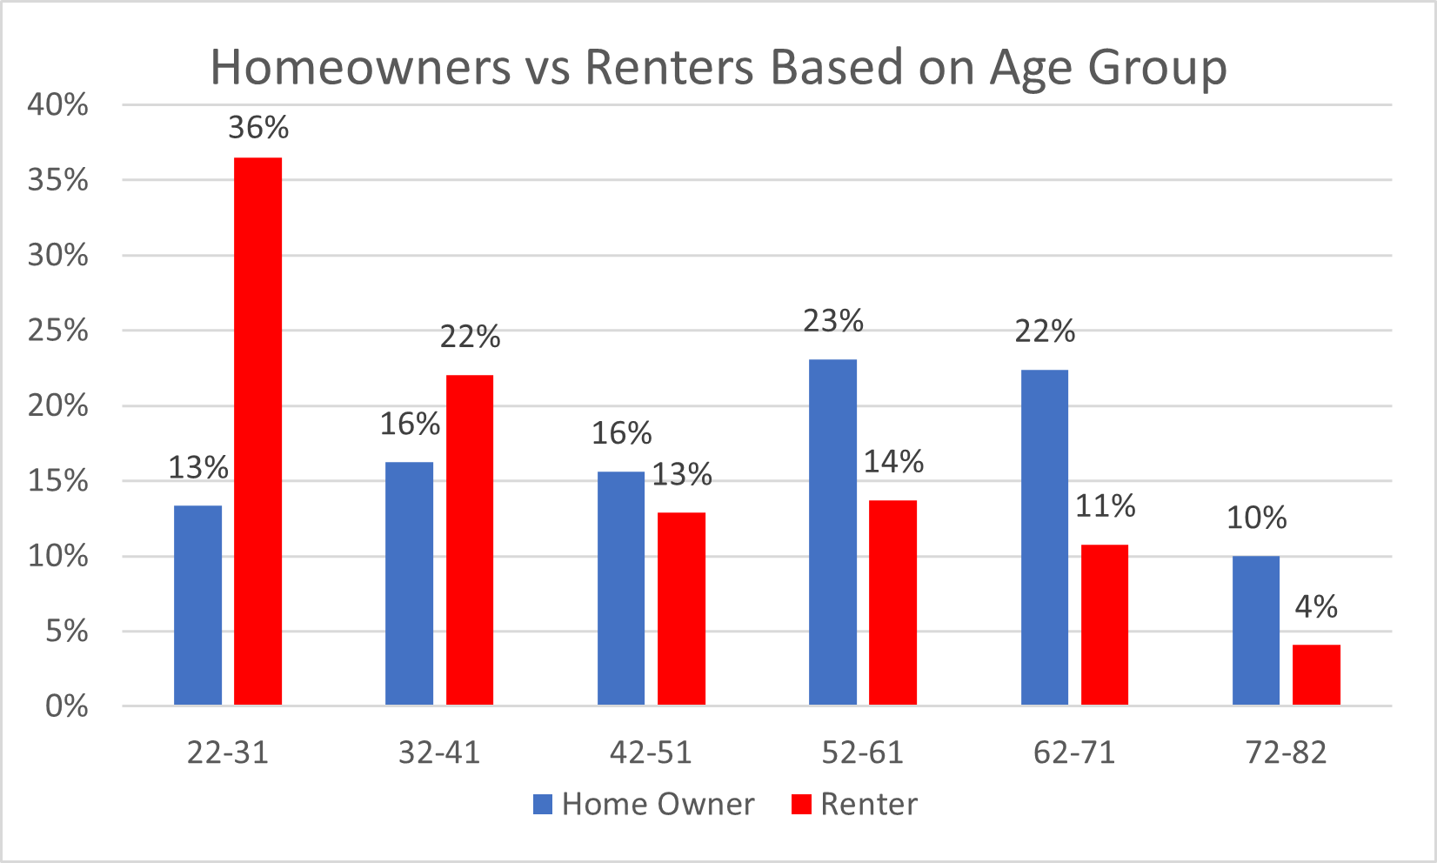

**Figure 2: Homeowners vs. Renters Based on Age Group**

About 36% of households preferred renting, and they are people who are between the ranges of 22-31. They are followed by individuals under the age of 32 and 41 in renting housing units, especially when they stay. On the other hand, Individuals owning houses stand at 23%, and the majority of these people fall under the age bracket of 52-61.

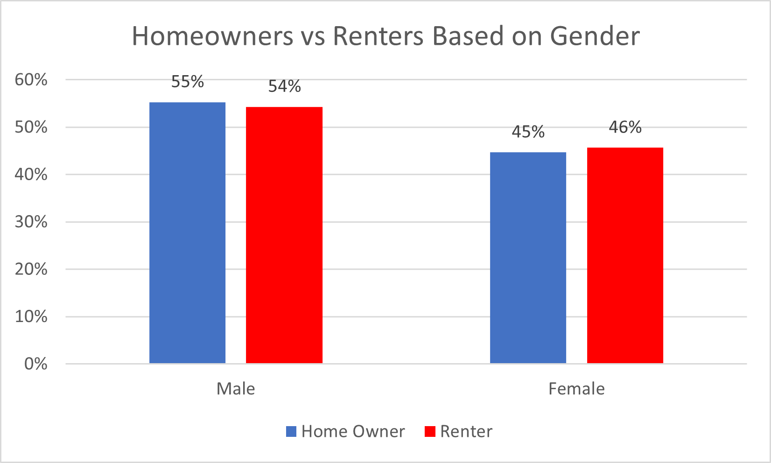

**Figure 3: Homeowners vs. Renters Based on Gender**

There is a significant difference based on gender. The male gender seems to be higher than the female gender in both homeownership and renting. Males have 55% for homeownership and 54% for renting. At the same time, females have 46% for rental and 45% for homeownership.

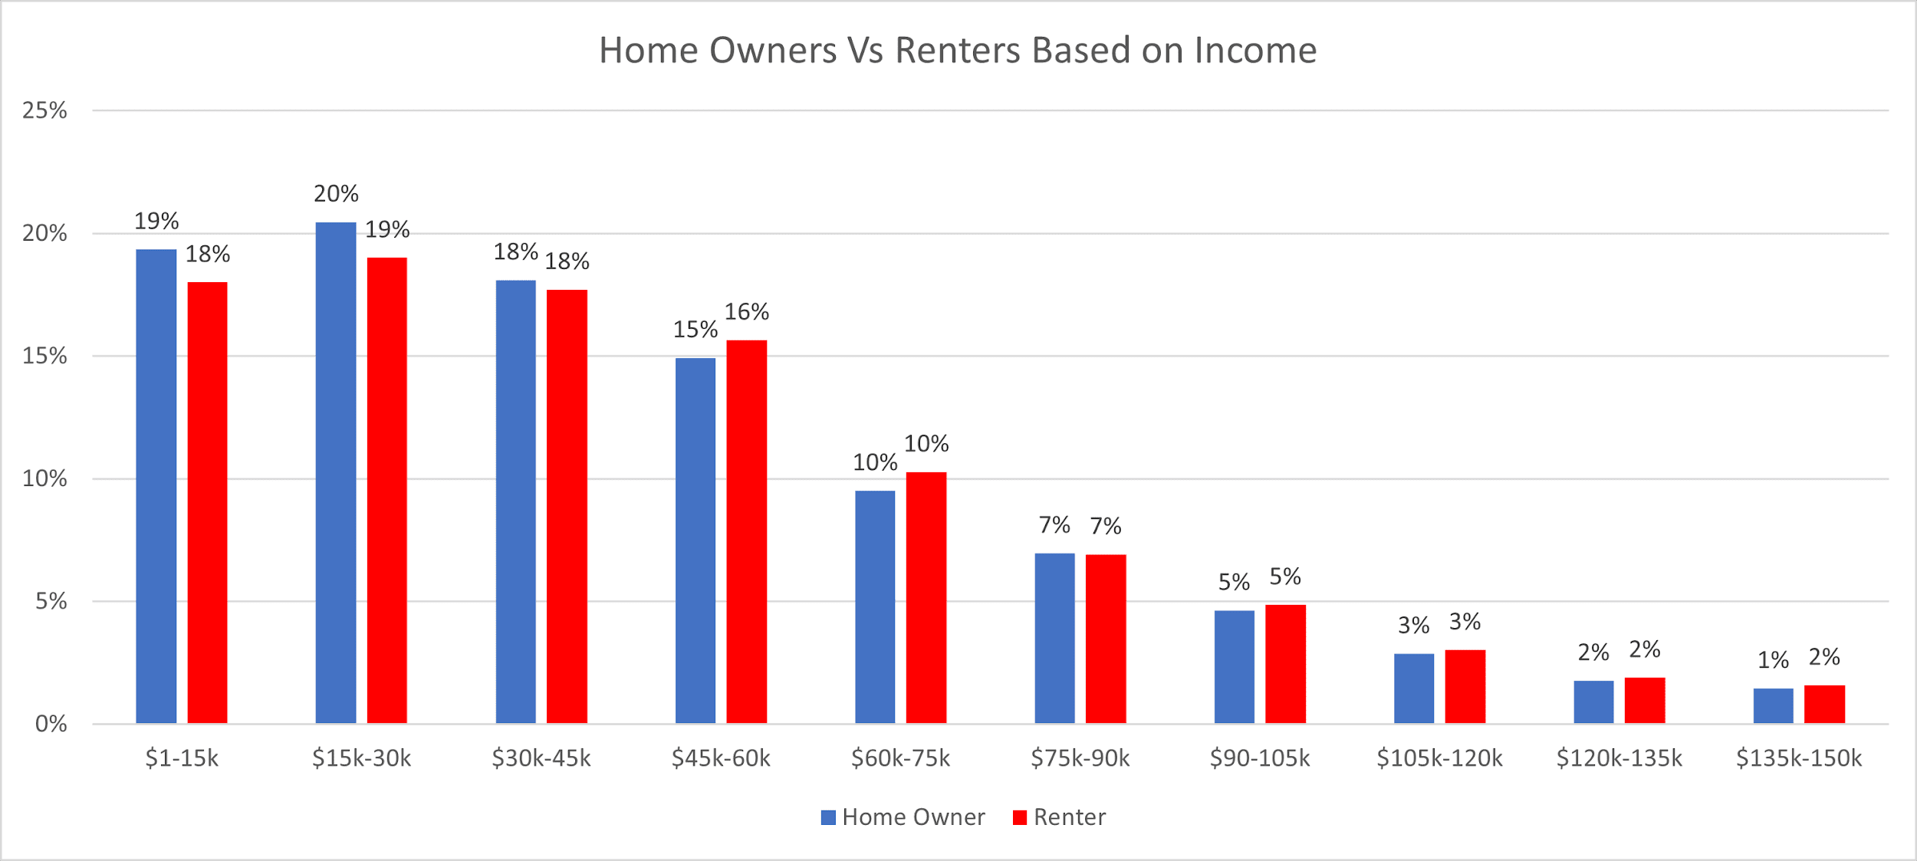

**Figure 4: Homeowners vs. Renters Based on Income**

The trend in homeownership and renting is the same. According to the data above, it shows that homeownership is more than renting. The urge to own or rent a housing unit reduces with the income of specific individuals. The highest homeownership based on gender is 20% falling under 15k-30k, and renting based on gender was indicated as 19%. It implies that people having a low income of about 15k and 30k have both the highest homeowners and renting.

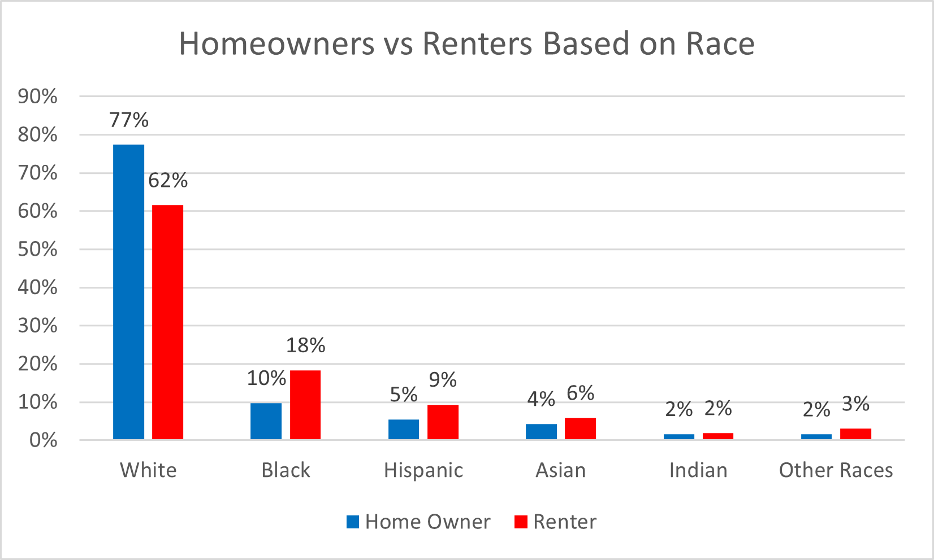

**Figure 5: Homeowners vs. Renters Based on Race**

Black and Hispanic individuals have about twice as likely as white people to rent their housing units. Whites lead in both homeowners and renters with 77% and 62%. These statistics could be different and most important when major racial and ethnic groups can rent housing units. Therefore, an increase in the rental rates will affect several families.

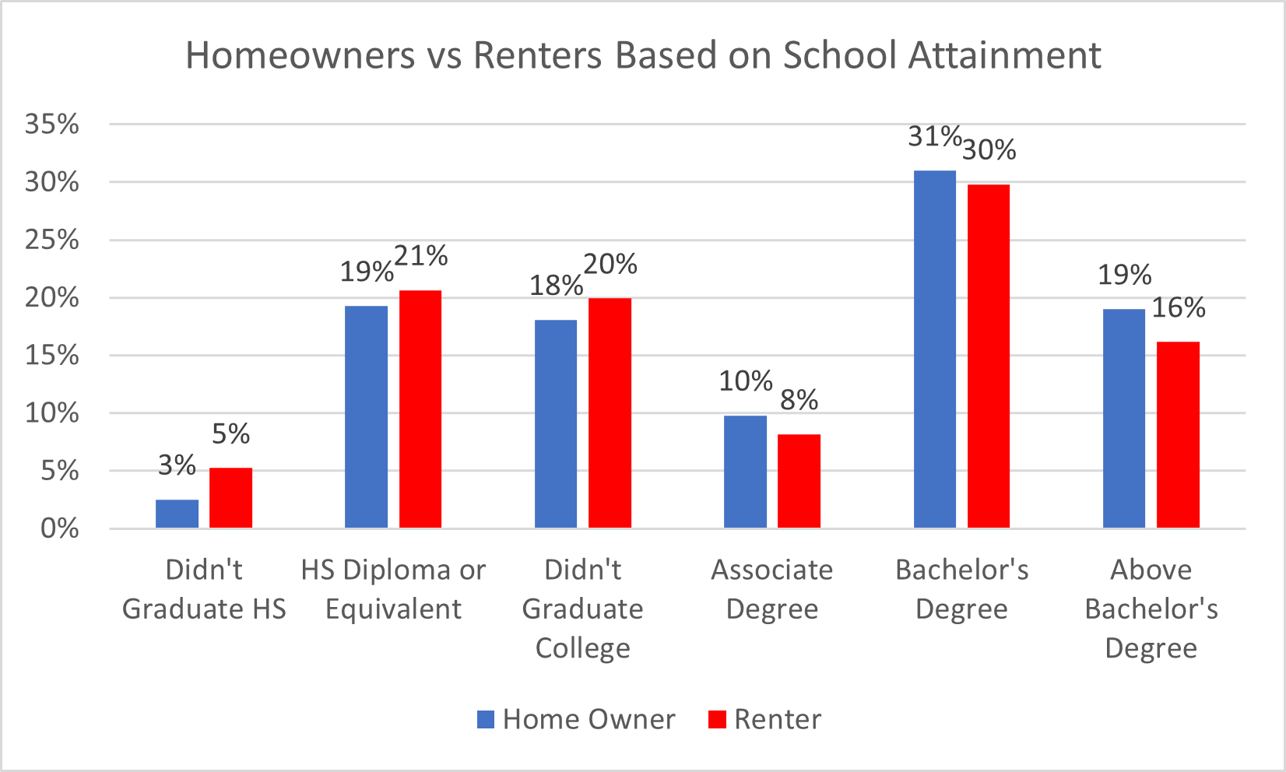

**Figure 6: Homeowners vs. Renters Based on School Attainment**

The movement toward homeowners and renting is also affected all levels of educational achievement. Ideally, from 2006 to 2019, rental rates have been increased among many people headed with someone who did not finish high school. College graduates tend more towards renting instead of owning housing units. The holders of Bachelor's Degree has 31% as a homeowner and renting at 30%. The margin is close; the homeowner is higher than renting.

**Data Insights**

The data visualizations can be used to build some conclusions about the data. After considering the data, it can be concluded that 60-70% were White and the rest of the categories making up that remaining 30%. The biased representation of this data is a concern. It must be quickly addressed rather than put aside, because if data is not processed correctly and accurately, it is still just information. Due to this, we cannot be 100% sure the correlations, lower instances of income, and the rest of the data wrangling is accurate.

Overall, it would be safe to say there are more renters in the age group 22-31 as compared to the others and more homeowners in the age group 52-61 as compared to the rest of the age groups, more male homeowners and renters as compared to the opposite sex and also people who have attained a Bachelor's degree tend more to be homeowners and renters.

**Recommendations/ Future Projects**

**Recommendations**

* Doing intensive research to develop a comprehensive reason to use data only in specific states to reduce the number of instances for smooth and effective use in excel.
* Would recommend taking time to learn programming languages applicable to excel, such as Python, C++, and C#, to ensure hassle-free data wrangling and save a lot more time.
* Taking time to read past data science reports in and out of the class to note do's, donts, vocabulary words, etc.

**Future Projects**

* Why do most intelligent wristwatch devices not capture accurate data on darker skin tones?
* The decrease or increase of homeowners and renters over the year.

**Insights from the Semester**

* We learned how to use excel in many ways. From the intensive wrangling of data to the creation of data visualizations through pivot tables and recommended charts.
* We learned how to analyze data from data analyzers' and scientists' perspectives to make it easier to finalize our datasheets, features, and instances to conduct an excellent report.
* We liked most about the course because it was the flexibility to develop our topics and the criticism and feedback to help steer us in the right direction.
* What we liked least was excel not being able to handle a tremendous amount of data, which ended up being time-consuming and resulted in less productivity.
* We also learned a lot of new things in CTEC 128. But the information we learned on the subject of data science was the most outstanding. Most of my team members and I had little to no experience in data science until this class. But afterward, we feel like we have a much better grasp of it.
* This course has prepared us to think like a data analyst; we learned about the three v's of Big data, which is very interesting. Overall this course was able to us with analyzing data.

**References**

Bijlsma, M., & Mocking, R. (2017). *The impact of house price shocks on dutch homeowners and renters* (No. 346. RDF). CPB Netherlands Bureau for Economic Policy Analysis.

Brunner, E. J., Ross, S. L., & Simonsen, B. K. (2015). Homeowners, renters, and the political economy of property taxation. *Regional Science and Urban Economics*, *53*, 38-49.

Diamond, R., Guren, A., & Tan, R. (2020). *The effect of foreclosures on homeowners, tenants, and landlords* (No. w27358). National Bureau of Economic Research.

Hankinson, M. (2018). When do renters behave like homeowners? High rent, price anxiety, and NIMBYism. *American Political Science Review*, *112*(3), 473-493.